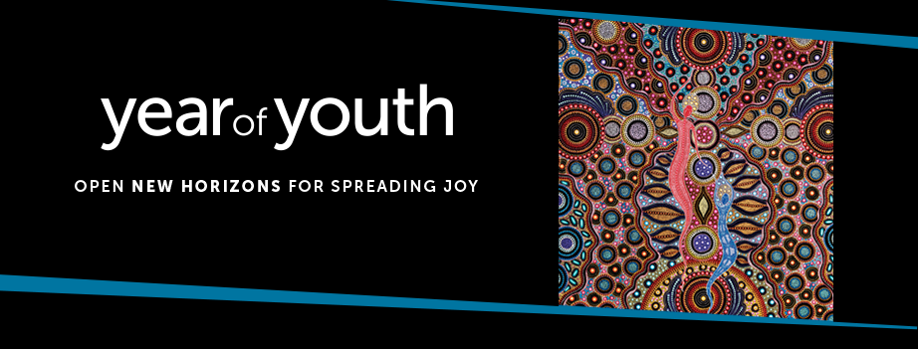

Year of Youth - Christ Our Joy

Use of Image Request

Name:
Organisation/ Parish / Diocese/ Community:
Postal Address:
Email:
Phone Number: |  | Mobile Number:

Description
Please describe how the image will be used. Include quantity and size of reproduction.
(Attach a sample if possible)

Use of Image Fees
It is at the discretion of the ACBC Office for Youth to charge a small fee for the supply of high resolution digital image and reproduction. Any fees collected will offset the cost of the commissioning and purchase of the artwork and will assist in the provision of resources for the Year of Youth.
Supply and use of a high-resolution image which may incur a small fee include: merchandising, resources for sale / profit/ cost recovery, reproduction of existing resources available for purchase through the ACBC Office for Youth (banners, promo material), reprints of the image and others at the discretion of the ACBC Office of Youth.

Complete and email to resources.youth@catholic.org.au (please allow 14 days for approval).

